Open Crochet Quick Start

**a mindfulness meditation practice**

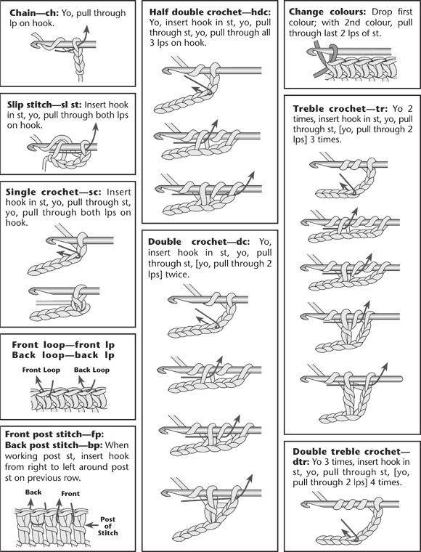

**Pattern:** hyperbolic surface   
**Stitch to know:** double  
**Why:**  learning a new skill and mindfulness are both great medicine for positivity and possibly more fun than traditional zen else to study exponential growth with satisfying yarn kale.

# HOLDING THE YARN

Right hand: hold the hook like a pencil. Pinkie & ring finger probably behind project.

Left hand: hold project with all fingers but first. Point first finger. Yarn goes from ball up inside the palm, between 1st and 2nd finger, and over the top of the 1st finger to the hook. 1st finger maintains a comfortable tension.

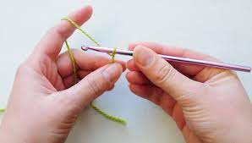

The project has been started for you to focus on the basic pattern first.

# BASIC PATTERN

1. Put 2 double crochet in each stitch

Repeat until you understand exponential growth. (Notice that every new row is more work than the entire project previously. Consider proving it to yourself by making one last row in another color once you finish your kit)

Switch in another color anytime for a satisfying stripe.

# HOW TO CROCHET HYPERBOLIC CORALS

# 

# STARTING

We’re making a spiral. Chain 4 to make a loop to work in. 2 single crochet inside, 2 half double, fill the loop with as many double crochet as fit inside comfortably, then start the basic pattern in the first single crochet and continue.

# 

# ENDING

Stop doubling. One double crochet in each of the next two stitches, then 2 half double in each of the next two, then 2 single, 2 slip stitch, then tie off and weave in the end.

<https://creativecommons.org/publicdomain/zero/1.0/>

Contact for more kits or other patterns: